Daily Report

Department: CSE - (CyS, DS) and AI&DS
Date:26-March-2026

- Staff Attendance:

S.No | Dept. | Category | On Rolls | Absent | Details/Remarks
 | CSE - (CyS, DS) and AI&DS | Teaching | 69 | 04 | Faculty – On Duty  Faculty – Casual / Earn Leave  a.Full Day  1. Dr. Talluri Sunil Kumar(01-03-26 to 30-06-26)  2. Mrs.V.Susmitha(04-03-2026 to 05-04-26)  3. Gandaboina Vanaja Kumari  4. Velpula Vinay Kumar  b. Half Day  1. Dr.Parimalla Subhash(FN)  1.Faculty – Half Pay Leave  1 Faculty - Study Leave  1.Mrs. Dr.T. Preethi  2.Ms.Issac Neha Margaret  3.Mr.K.Sai Bhargav  0 Faculty - Maternity/Paternity Leave
 |  | Non- Teaching | 13 | 02 | 0 Staff– On Duty  Staff- Casual / Earn Leave  a.Full  1. Tummala Venkata Santhosha Lakshmi Bhavani  2. Dupaguntla Subha  - Staff– Half Pay Leave  0 Staff -Study Leave  1 Staff – Maternity/Paternity Leave  - Mrs. A. Shobha

- Infrastructure issues or Maintenance:

S.No. | Description of the problem | Reported  On | Attended  On | Completed on | Remarks
1.

- Event (short term course / workshops/Seminar, etc.) organized:

S.No | Name of the Event-seminar/ short term course / workshops,etc | Duration | For Whom | No. of Participants |  | Resource  Person/Faculty | Remarks
 |  |  |  | VNRVJIET | Others

- Participation by Staff & Students

S. No | Name | Event | Status | Date and Duration

Participation by Staff and Students:

S. No | Name | Event | Status (delegate /paper) Present, speaker) | Date and Duration
- Staff joined or left

S.No | Name of the Faculty | Designation | Date of Joining/leaving | Remarks
1

- Classwork Adjustment / Lectures Interchanged:
S. No | Dept | Subject | Time | Adjusted from | Adjusted to
1 | CSE-(CyS,DS) and AI&DS

S.No | Name | R. No. or ID No. | Brief statement | Remarks

- Any other matter to be reported: 26-03-2026

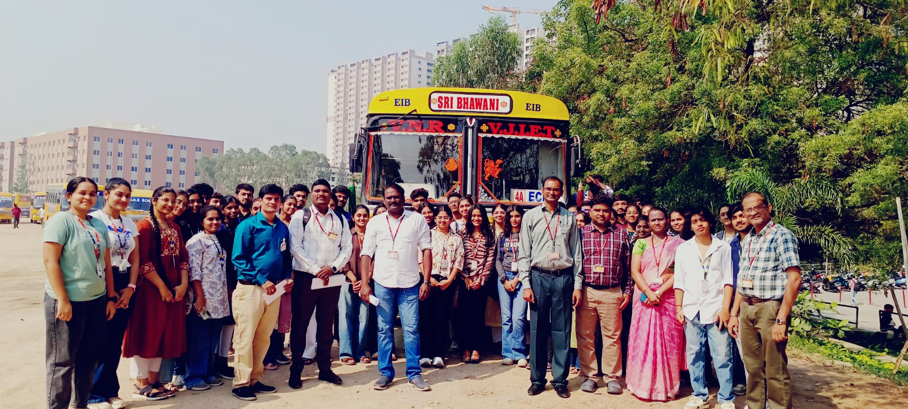

We are delighted to share that we have commenced our Industrial Visit to T-Hub along with our students.

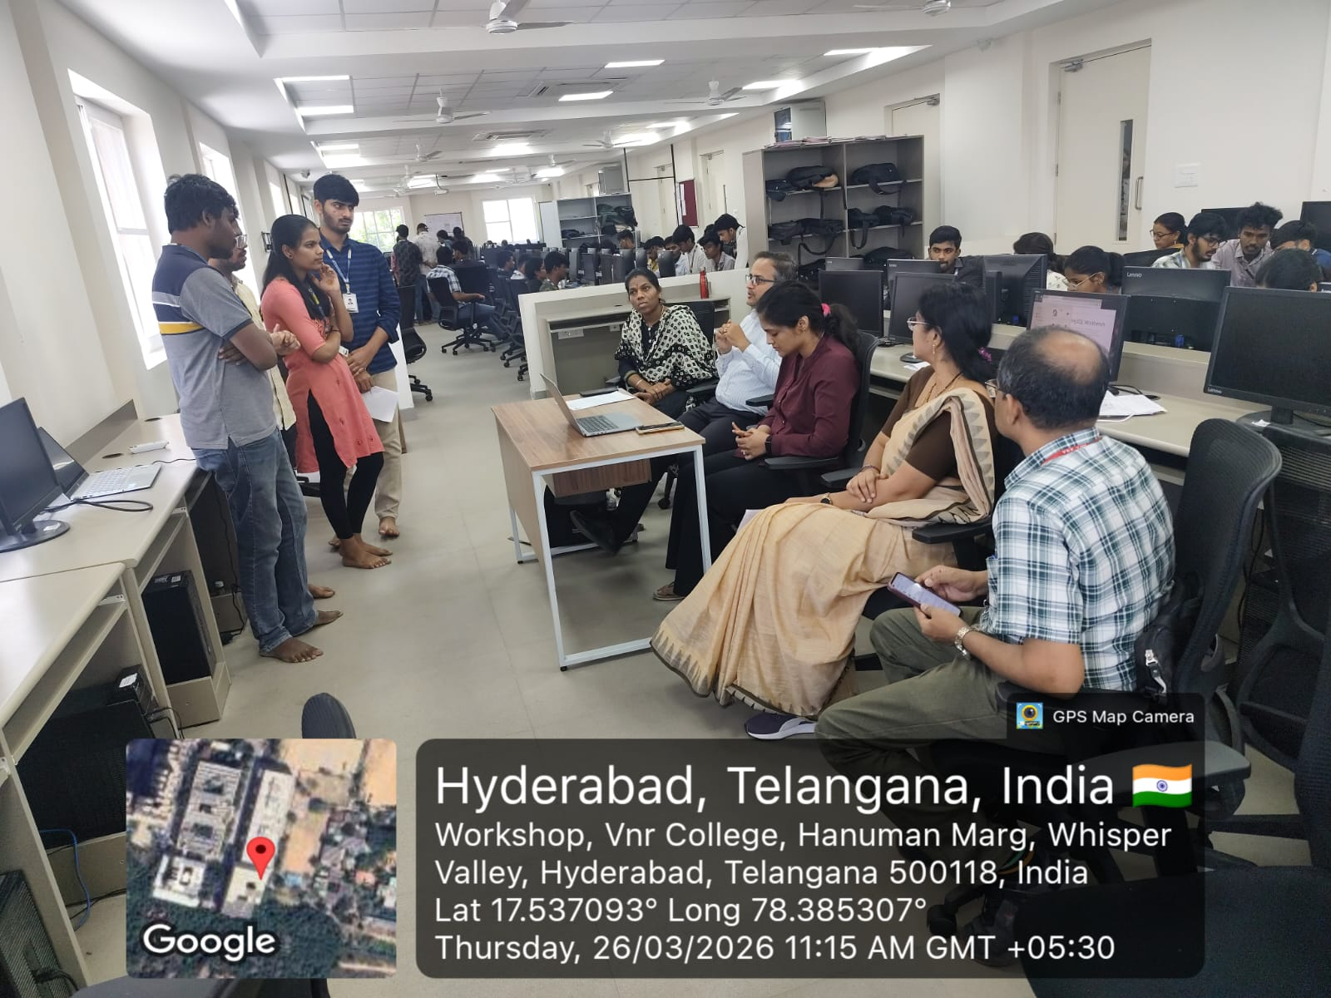
E. Lalitha madam, Sneha PoP madam , Anand Kumar PoP sir and Manmath sir are conducting Reviews in E-317 for III year AI&DS .
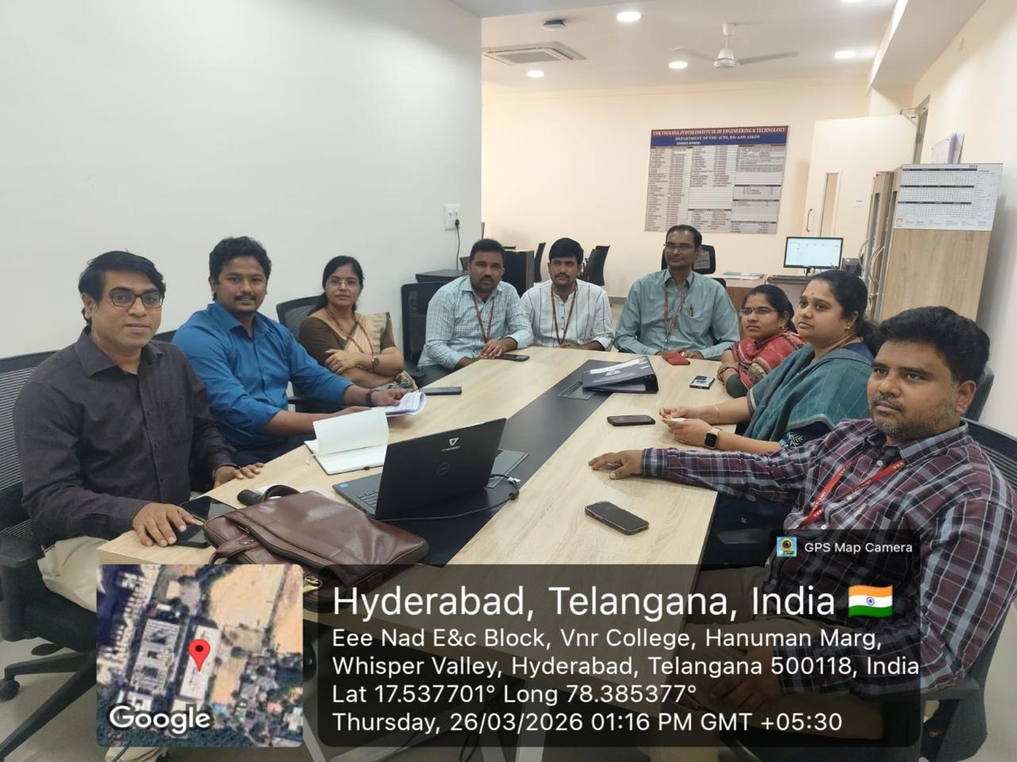
Interaction with K7 Enterprise Security experts regarding cyber security activities in the department.
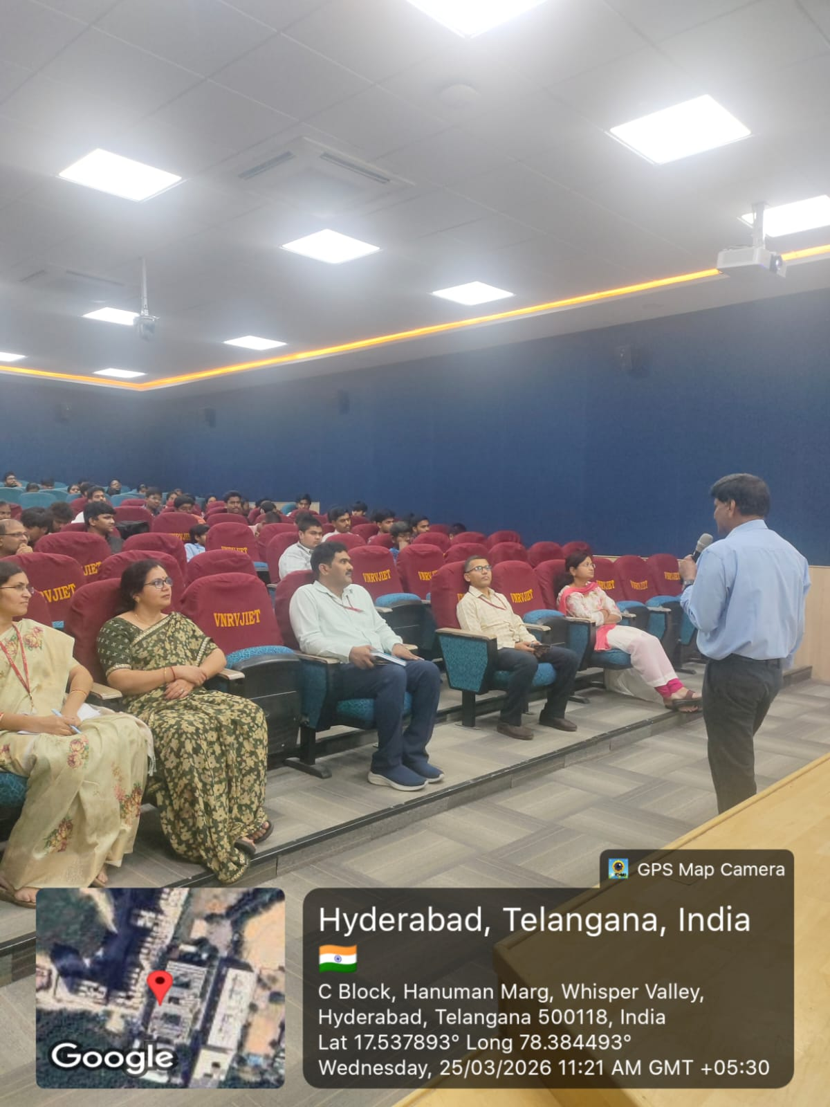
An expert talk on “Strategic Approaches to Patentable Innovations and High-Quality Patent Drafting” was conducted at VNR VJIET on 25th March 2026 at B block seminar hall from 10:30 AM to 1:00 PM. The session was delivered by Mr. B. Satyanarayana, retired as AGM, BHEL and coordinated by Dr. Mule Laxmidevi Ramanaiah, Assistant Professor, Dept. of CSE(CyS,DS) and AI&DS, VNR VJIET under the convenership of Dr. Ajay Kumar Kaviti, Professor,Head of IPR cell and Dr. D Manju, Assistant Professor, Dept. of CSE(CyS,DS) and AI&DS, VNR VJIET. Around 100 participants, including faculty and students, attended the session, which provided valuable insights into intellectual property rights, patentable ideas, and drafting techniques. The event concluded with felicitation and a vote of thanks.

Dr. G.Ramesh Chandra

Prof. & I/C HoD
CSE-(CyS, DS) and AI&DS

